Parameter Creater

This web application will update 9 files.

1. PARAMNUM.H
2. parstruc.h
3. attribute_list.i
4. attribute_info.i
5. attribute_access.h
6. attribute_access.c
7. DEFTABLE.I
8. parinfo.i
9. description.json

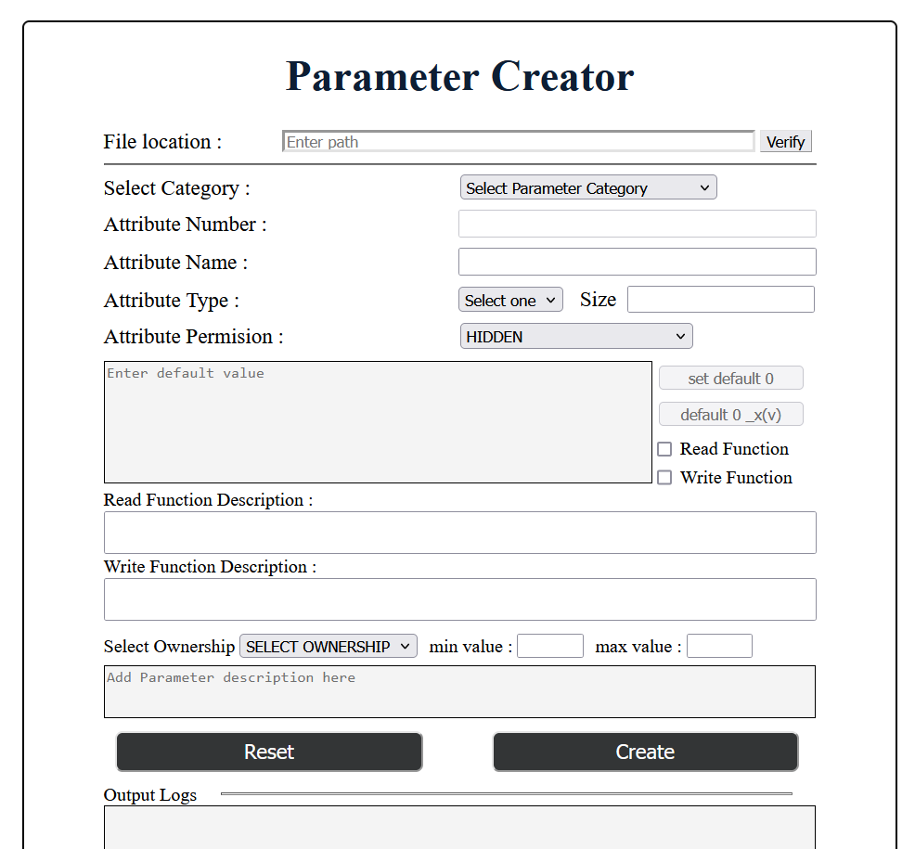

When the folder path will be give to the file location input box it will automatically check the above files exist. Here **description.json** should not be there. If **description.json** is not in the folder it will automatically ceated at the location **Deftable.i** exist. If the above all the files except description.json can be found in the folder then the border color will be turn into green. Otherwise it will be tern into red color. When we press the **verify** button the status will be printed in the output logs pannel.

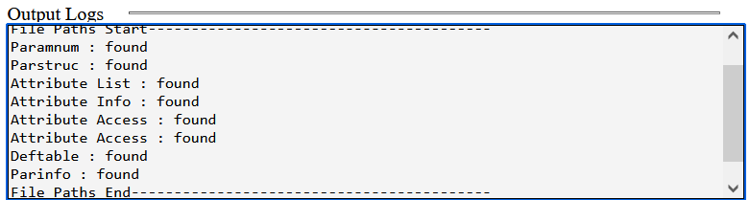

When parameter catogorty is selected it will display the next parameter number in the Attribute Number area. Here it will search next parameter number in the attribute_list.i file. for that I have added comments as follows,





above is an example for system parameters.

But **SCANNER_STATISTICS** parameters are not in the **attribute_list.i .** So, if user select that parameter catogory the next attribute number will be find from **Paramnum.H** file.

When user enter a new parameter there will be some validations before write it into files,

1. Parameter Name should consist only alphabets and numbers.
2. If parameter has any spaces application should replace them with “_” before write into files.
3. Defalt value should be validate to check it is in correct format.

Here attribute size input box will not be opened for the FLAG, WORD, DWORD barameter types. It will be automatically set by the application,

for, FLAG – 1 Bit

WORD – 1 Byte

DWORD – 2 Bytes

for the other types of parameters, parameter sizes will be entered by the user.

If the user select string as parameter type, then the “set default 0” and “default 0 _X(v)” buttons will be enabled. These buttons can be used to fill the default value input box with zeros. Then user can do the requared changes and create this parameter.

Before working with this application add following lines to the 8 files.

**PARAMNUM.H**

this file should consider only for the **system parameters** and **scanner statistics** type of parameters. So we have to add the comment // ATAG SYSTEM_PARAMETER START at the line the system parameters start. at the end of the system parameters end // ATAG SYSTEM_PARAMETER END comment line should be added. like wise at the line scanner statistics parameters start you have to add the comment // ATAG SCANNER_STATISTICS START and at the line this parameter type will end // ATAG SCANNER_STATISTICS END.

**parstruc.h**

At the end of the parstruct parameters // FLAG END SPARES 3 28 This comment line should be added. here 3 means number of spares in the above flag parameter set. 28 is the hexadecimal number that means 28th set.

at the end of every parameter type you should add this kind of comments.

**attribute_list.i**

// ATAG SYSTEM_PARAMETER START

system parameters

// ATAG SYSTEM_PARAMETER END 2468

Here 2468 is the next parameter number for the system parameters. This kind of comments should be added for the other parameter types as well.

**attribute_info.i**

// ATAG SYSTEM_PARAMETER END 2468

for the other files same method should be applied.